**LAPORAN PRAKTIKUM BAHASA PEMROGRAMAN 1**

**MODUL 7 : CRUD (Create, Read)**

Nama : Ilham Hafidz

NIM : 20220810052

Kelas : TINFC-2022-01

POSTTEST

1. Lengkapi program, jika tombol simpan di klik akan menampilkan YESNOQuestion untuk penyimpanan data.
2. Jika tombol simpan di klik. Form Input Data akan kembali kosong seperti kondisi awal
3. Jika tombol simpan diklik, data yang diinput akan langsung tampil pada Jtable

Jawab :

|  |
| --- |
| **File BP1_M6_P1_IlhamHafidz** |
| import java.sql.ResultSet;  import java.sql.Statement;  import javax.swing.JOptionPane;  import javax.swing.table.DefaultTableModel;  import java.sql.SQLException;  public class BP1_M6_P1_IlhamHafidz extends javax.swing.JFrame {    Statement st;  ResultSet rs;  koneksi koneksi;  public BP1_M6_P1_IlhamHafidz() {  koneksi= new koneksi();  initComponents();    load_data();  }    private void load_data(){  Object header[]= {"NIM", "Nama", "Jenis Kelamin", "Prodi", "Alamat", "Kelas", "Angkatan", "No.HP"};  DefaultTableModel data= new DefaultTableModel(null, header);  tableDataMahasiswa.setModel(data);    String sql= "SELECT * FROM mhs";    try{  st= koneksi.con.createStatement();  rs= st.executeQuery(sql);    while(rs.next()){  String k1= rs.getString(1);  String k2= rs.getString(2);  String k3= rs.getString(3);  String k4= rs.getString(4);  String k5= rs.getString(5);  String k6= rs.getString(6);  String k7= rs.getString(7);  String k8= rs.getString(8);    String k[]= {k1, k2, k3, k4, k5, k6, k7, k8};  data.addRow(k);  }  } catch(SQLException e) {  JOptionPane.showMessageDialog(null, e);  }  }    private void input_data(){  try {  String jk= "";  if(radioButtonPerempuan.isSelected()){  jk= radioButtonPerempuan.getText();  } else{  jk= radioButtonLakiLaki.getText();  }    String sql= "INSERT INTO mhs VALUES('"+  textFieldNIM.getText() + "', '" +  textFieldNama.getText() + "', '" +  jk + "', '" +  comboBoxProdi.getSelectedItem() + "', '" +  textAreaAlamat.getText() + "', '" +  textFieldKelas.getText() +"', '" +  textFieldAngkatan.getText() + "', '" +  textFieldHP.getText() + "')";    st.execute(sql);  load_data();    JOptionPane.showMessageDialog(null, "Data Mahasiswa Berhasil Diinput");  } catch (SQLException e){  JOptionPane.showMessageDialog(null, e);  }  }    private void reset(){  textFieldNIM.setText("");  textFieldNama.setText("");  comboBoxProdi.setSelectedItem("Teknik Informatika");  textAreaAlamat.setText("");  textFieldKelas.setText("");  textFieldAngkatan.setText("");  textFieldHP.setText("");  }    @SuppressWarnings("unchecked")  // <editor-fold defaultstate="collapsed" desc="Generated Code">  private void initComponents() {  labelTitle = new javax.swing.JLabel();  labelSubtitle = new javax.swing.JLabel();  labelNIM = new javax.swing.JLabel();  labelNama = new javax.swing.JLabel();  labelJenisKelamin = new javax.swing.JLabel();  labelProdi = new javax.swing.JLabel();  labelAlamat = new javax.swing.JLabel();  textFieldNIM = new javax.swing.JTextField();  textFieldNama = new javax.swing.JTextField();  jScrollPane1 = new javax.swing.JScrollPane();  textAreaAlamat = new javax.swing.JTextArea();  comboBoxProdi = new javax.swing.JComboBox<>();  radioButtonLakiLaki = new javax.swing.JRadioButton();  radioButtonPerempuan = new javax.swing.JRadioButton();  buttonSimpan = new javax.swing.JButton();  jLabel1 = new javax.swing.JLabel();  jScrollPane2 = new javax.swing.JScrollPane();  tableDataMahasiswa = new javax.swing.JTable();  labelKelas = new javax.swing.JLabel();  textFieldKelas = new javax.swing.JTextField();  labelAngkatan = new javax.swing.JLabel();  textFieldAngkatan = new javax.swing.JTextField();  labelNoHP = new javax.swing.JLabel();  textFieldHP = new javax.swing.JTextField();  setDefaultCloseOperation(javax.swing.WindowConstants.EXIT_ON_CLOSE);  labelTitle.setText("DATA MAHASISWA");  labelSubtitle.setText("FORM INPUT DATA");  labelNIM.setText("NIM");  labelNama.setText("Nama");  labelJenisKelamin.setText("Jenis Kelamin");  labelProdi.setText("Prodi");  labelAlamat.setText("Alamat");  textAreaAlamat.setColumns(20);  textAreaAlamat.setRows(5);  textAreaAlamat.setPreferredSize(new java.awt.Dimension(60, 84));  jScrollPane1.setViewportView(textAreaAlamat);  comboBoxProdi.setModel(new javax.swing.DefaultComboBoxModel<>(new String[] { "Teknik Informatika", "Sistem Informasi", "Desain Komunikasi Visual", "Manajemen Informatika", "Teknik Sipil", " " }));  radioButtonLakiLaki.setText("L");  radioButtonPerempuan.setText("P");  buttonSimpan.setText("Simpan");  buttonSimpan.addMouseListener(new java.awt.event.MouseAdapter() {  public void mouseClicked(java.awt.event.MouseEvent evt) {  buttonSimpanMouseClicked(evt);  }  });  jLabel1.setText("DATA MAHASISWA");  tableDataMahasiswa.setModel(new javax.swing.table.DefaultTableModel(  new Object [][] {  {null, null, null, null},  {null, null, null, null},  {null, null, null, null},  {null, null, null, null}  },  new String [] {  "Title 1", "Title 2", "Title 3", "Title 4"  }  ));  jScrollPane2.setViewportView(tableDataMahasiswa);  labelKelas.setText("Kelas");  labelAngkatan.setText("Angkatan");  labelNoHP.setText("No HP");  javax.swing.GroupLayout layout = new javax.swing.GroupLayout(getContentPane());  getContentPane().setLayout(layout);  layout.setHorizontalGroup(  layout.createParallelGroup(javax.swing.GroupLayout.Alignment.LEADING)  .addGroup(layout.createSequentialGroup()  .addGap(223, 223, 223)  .addComponent(labelTitle)  .addContainerGap(javax.swing.GroupLayout.DEFAULT_SIZE, Short.MAX_VALUE))  .addGroup(layout.createSequentialGroup()  .addGroup(layout.createParallelGroup(javax.swing.GroupLayout.Alignment.LEADING)  .addGroup(layout.createSequentialGroup()  .addGap(119, 119, 119)  .addComponent(labelSubtitle))  .addGroup(layout.createSequentialGroup()  .addGroup(layout.createParallelGroup(javax.swing.GroupLayout.Alignment.LEADING)  .addGroup(layout.createSequentialGroup()  .addGap(34, 34, 34)  .addGroup(layout.createParallelGroup(javax.swing.GroupLayout.Alignment.LEADING)  .addComponent(labelNIM, javax.swing.GroupLayout.PREFERRED_SIZE, 37, javax.swing.GroupLayout.PREFERRED_SIZE)  .addComponent(labelNama, javax.swing.GroupLayout.PREFERRED_SIZE, 37, javax.swing.GroupLayout.PREFERRED_SIZE)  .addComponent(labelProdi, javax.swing.GroupLayout.PREFERRED_SIZE, 37, javax.swing.GroupLayout.PREFERRED_SIZE)  .addComponent(labelJenisKelamin)  .addGroup(layout.createParallelGroup(javax.swing.GroupLayout.Alignment.TRAILING)  .addComponent(labelKelas, javax.swing.GroupLayout.PREFERRED_SIZE, 37, javax.swing.GroupLayout.PREFERRED_SIZE)  .addComponent(labelAlamat)))  .addGap(51, 51, 51))  .addGroup(javax.swing.GroupLayout.Alignment.TRAILING, layout.createSequentialGroup()  .addContainerGap()  .addGroup(layout.createParallelGroup(javax.swing.GroupLayout.Alignment.LEADING)  .addComponent(labelNoHP, javax.swing.GroupLayout.PREFERRED_SIZE, 37, javax.swing.GroupLayout.PREFERRED_SIZE)  .addComponent(labelAngkatan))  .addGap(71, 71, 71)))  .addGroup(layout.createParallelGroup(javax.swing.GroupLayout.Alignment.LEADING, false)  .addGroup(layout.createSequentialGroup()  .addComponent(radioButtonLakiLaki, javax.swing.GroupLayout.PREFERRED_SIZE, 98, javax.swing.GroupLayout.PREFERRED_SIZE)  .addPreferredGap(javax.swing.LayoutStyle.ComponentPlacement.RELATED)  .addComponent(radioButtonPerempuan, javax.swing.GroupLayout.PREFERRED_SIZE, 98, javax.swing.GroupLayout.PREFERRED_SIZE))  .addComponent(textFieldNama)  .addComponent(textFieldNIM)  .addComponent(jScrollPane1)  .addComponent(comboBoxProdi, 0, javax.swing.GroupLayout.DEFAULT_SIZE, Short.MAX_VALUE)  .addComponent(buttonSimpan)  .addComponent(textFieldKelas)  .addComponent(textFieldAngkatan)  .addComponent(textFieldHP))))  .addPreferredGap(javax.swing.LayoutStyle.ComponentPlacement.RELATED, 74, Short.MAX_VALUE)  .addGroup(layout.createParallelGroup(javax.swing.GroupLayout.Alignment.LEADING)  .addGroup(javax.swing.GroupLayout.Alignment.TRAILING, layout.createSequentialGroup()  .addComponent(jLabel1)  .addGap(202, 202, 202))  .addGroup(javax.swing.GroupLayout.Alignment.TRAILING, layout.createSequentialGroup()  .addComponent(jScrollPane2, javax.swing.GroupLayout.PREFERRED_SIZE, 607, javax.swing.GroupLayout.PREFERRED_SIZE)  .addGap(25, 25, 25))))  );  layout.setVerticalGroup(  layout.createParallelGroup(javax.swing.GroupLayout.Alignment.LEADING)  .addGroup(layout.createSequentialGroup()  .addGap(16, 16, 16)  .addComponent(labelTitle)  .addGap(33, 33, 33)  .addGroup(layout.createParallelGroup(javax.swing.GroupLayout.Alignment.BASELINE)  .addComponent(labelSubtitle)  .addComponent(jLabel1))  .addGap(32, 32, 32)  .addGroup(layout.createParallelGroup(javax.swing.GroupLayout.Alignment.LEADING)  .addComponent(jScrollPane2, javax.swing.GroupLayout.PREFERRED_SIZE, 179, javax.swing.GroupLayout.PREFERRED_SIZE)  .addGroup(layout.createSequentialGroup()  .addGroup(layout.createParallelGroup(javax.swing.GroupLayout.Alignment.BASELINE)  .addComponent(labelNIM)  .addComponent(textFieldNIM, javax.swing.GroupLayout.PREFERRED_SIZE, javax.swing.GroupLayout.DEFAULT_SIZE, javax.swing.GroupLayout.PREFERRED_SIZE))  .addGap(18, 18, 18)  .addGroup(layout.createParallelGroup(javax.swing.GroupLayout.Alignment.BASELINE)  .addComponent(labelNama)  .addComponent(textFieldNama, javax.swing.GroupLayout.PREFERRED_SIZE, javax.swing.GroupLayout.DEFAULT_SIZE, javax.swing.GroupLayout.PREFERRED_SIZE))  .addGap(18, 18, 18)  .addGroup(layout.createParallelGroup(javax.swing.GroupLayout.Alignment.BASELINE)  .addComponent(labelJenisKelamin)  .addComponent(radioButtonLakiLaki)  .addComponent(radioButtonPerempuan))  .addGap(18, 18, 18)  .addGroup(layout.createParallelGroup(javax.swing.GroupLayout.Alignment.BASELINE)  .addComponent(labelProdi)  .addComponent(comboBoxProdi, javax.swing.GroupLayout.PREFERRED_SIZE, javax.swing.GroupLayout.DEFAULT_SIZE, javax.swing.GroupLayout.PREFERRED_SIZE))  .addGap(18, 18, 18)  .addGroup(layout.createParallelGroup(javax.swing.GroupLayout.Alignment.LEADING)  .addComponent(labelAlamat)  .addComponent(jScrollPane1, javax.swing.GroupLayout.PREFERRED_SIZE, javax.swing.GroupLayout.DEFAULT_SIZE, javax.swing.GroupLayout.PREFERRED_SIZE))  .addGap(18, 18, 18)  .addGroup(layout.createParallelGroup(javax.swing.GroupLayout.Alignment.BASELINE)  .addComponent(textFieldKelas, javax.swing.GroupLayout.PREFERRED_SIZE, javax.swing.GroupLayout.DEFAULT_SIZE, javax.swing.GroupLayout.PREFERRED_SIZE)  .addComponent(labelKelas))))  .addGap(18, 18, 18)  .addGroup(layout.createParallelGroup(javax.swing.GroupLayout.Alignment.BASELINE)  .addComponent(labelAngkatan)  .addComponent(textFieldAngkatan, javax.swing.GroupLayout.PREFERRED_SIZE, javax.swing.GroupLayout.DEFAULT_SIZE, javax.swing.GroupLayout.PREFERRED_SIZE))  .addGap(18, 18, 18)  .addGroup(layout.createParallelGroup(javax.swing.GroupLayout.Alignment.BASELINE)  .addComponent(labelNoHP)  .addComponent(textFieldHP, javax.swing.GroupLayout.PREFERRED_SIZE, javax.swing.GroupLayout.DEFAULT_SIZE, javax.swing.GroupLayout.PREFERRED_SIZE))  .addPreferredGap(javax.swing.LayoutStyle.ComponentPlacement.RELATED, 30, Short.MAX_VALUE)  .addComponent(buttonSimpan)  .addGap(20, 20, 20))  );  pack();  }// </editor-fold>  private void buttonSimpanMouseClicked(java.awt.event.MouseEvent evt) {  // input_data();  int confirmSelected= JOptionPane.showConfirmDialog(  null,  "Apakah Yakin Data Mahasiswa akan ditambahkan?",  "Konfirmasi",  JOptionPane.YES_NO_OPTION  );    if(confirmSelected == 0){  input_data();  }    reset();  }  public static void main(String args[]) {  try {  for (javax.swing.UIManager.LookAndFeelInfo info : javax.swing.UIManager.getInstalledLookAndFeels()) {  if ("Nimbus".equals(info.getName())) {  javax.swing.UIManager.setLookAndFeel(info.getClassName());  break;  }  }  } catch (ClassNotFoundException ex) {  java.util.logging.Logger.getLogger(BP1_M6_P1_IlhamHafidz.class.getName()).log(java.util.logging.Level.SEVERE, null, ex);  } catch (InstantiationException ex) {  java.util.logging.Logger.getLogger(BP1_M6_P1_IlhamHafidz.class.getName()).log(java.util.logging.Level.SEVERE, null, ex);  } catch (IllegalAccessException ex) {  java.util.logging.Logger.getLogger(BP1_M6_P1_IlhamHafidz.class.getName()).log(java.util.logging.Level.SEVERE, null, ex);  } catch (javax.swing.UnsupportedLookAndFeelException ex) {  java.util.logging.Logger.getLogger(BP1_M6_P1_IlhamHafidz.class.getName()).log(java.util.logging.Level.SEVERE, null, ex);  }  java.awt.EventQueue.invokeLater(new Runnable() {  public void run() {  new BP1_M6_P1_IlhamHafidz().setVisible(true);  }  });  }  // Variables declaration - do not modify  private javax.swing.JButton buttonSimpan;  private javax.swing.JComboBox<String> comboBoxProdi;  private javax.swing.JLabel jLabel1;  private javax.swing.JScrollPane jScrollPane1;  private javax.swing.JScrollPane jScrollPane2;  private javax.swing.JLabel labelAlamat;  private javax.swing.JLabel labelAngkatan;  private javax.swing.JLabel labelJenisKelamin;  private javax.swing.JLabel labelKelas;  private javax.swing.JLabel labelNIM;  private javax.swing.JLabel labelNama;  private javax.swing.JLabel labelNoHP;  private javax.swing.JLabel labelProdi;  private javax.swing.JLabel labelSubtitle;  private javax.swing.JLabel labelTitle;  private javax.swing.JRadioButton radioButtonLakiLaki;  private javax.swing.JRadioButton radioButtonPerempuan;  private javax.swing.JTable tableDataMahasiswa;  private javax.swing.JTextArea textAreaAlamat;  private javax.swing.JTextField textFieldAngkatan;  private javax.swing.JTextField textFieldHP;  private javax.swing.JTextField textFieldKelas;  private javax.swing.JTextField textFieldNIM;  private javax.swing.JTextField textFieldNama;  // End of variables declaration  } |

Output :

* Mengisi form input data

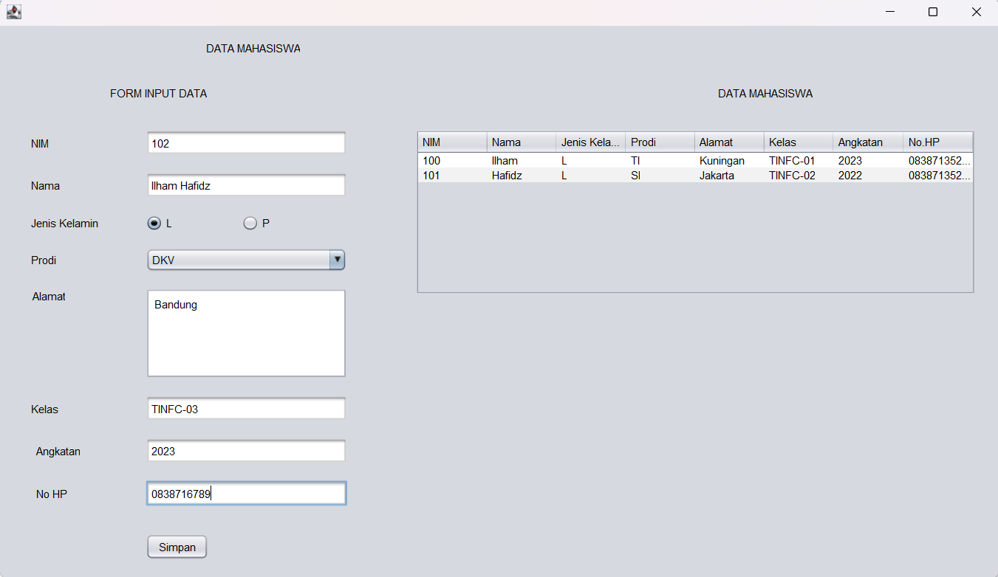

* Ketika klik simpan akan muncul konfirmasi (YES & NO Question)  
  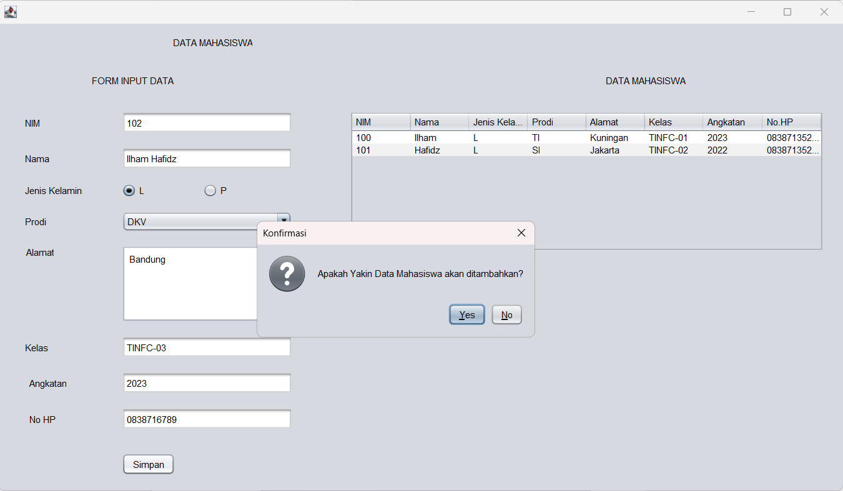
* Jika klik yes, maka data akan diinputkan dan diinsert kedalam table dan muncul message bahwa data berhasil diinput

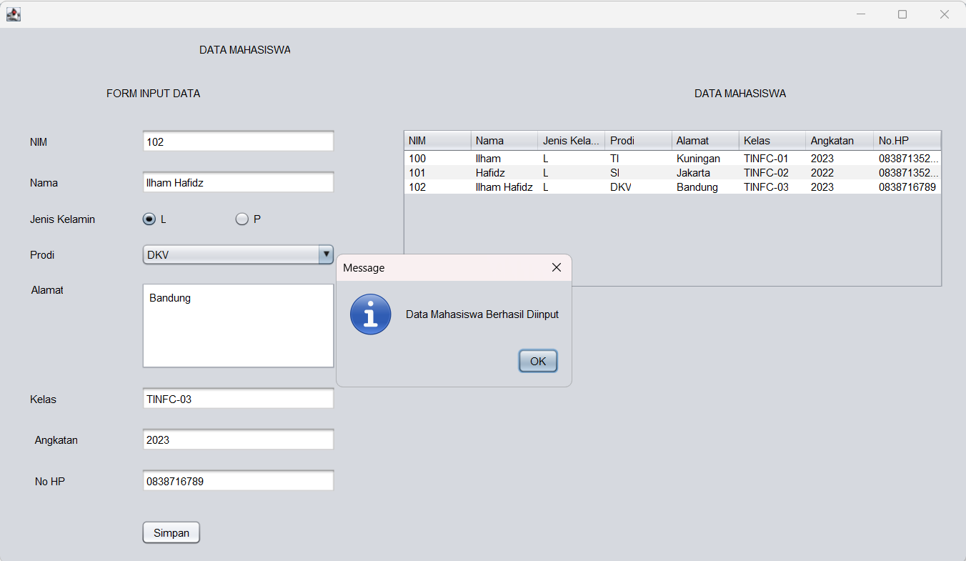

* Ketika pop up message di close (klik tombol ok) maka form inputan di reset.

